Assignment 2: Detail Design

Pipe bending machine.

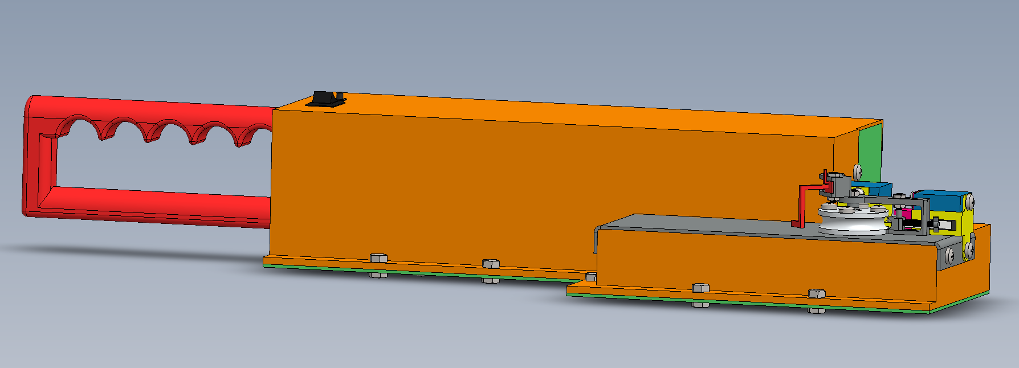

Figure 1 CAD Model of a pipe bending tool

The model shows a red handle at the back, with two switches (push and control switch) close to it. The lower casing is shown in green and the upper casing is shown in orange. At the front there’s a front casing made with sheet metal shown in grey. On top of the front casing there’s a big roller, clamp, angle control mechanism and limit switches safely secured in their holders. On the outside there are fasteners to hold the part together.

PLAGIARISM declaration

1. I know that plagiarism is wrong. Plagiarism is to use another’s work and pretends that it is one’s own.
2. Each significant contribution to, and quotation in this assignment from the work(s) of other people has been attributed and has been cited and referenced.
3. This assignment is my/our own work.
4. I have not allowed and will not allow anyone to copy this work with the intention of passing it off as his or her own work.
5. By filling in my full names, I am formally signing this declaration and declares I have abided by the rules.

Document AUTHOR

| Student Number | Full Names |
| --- | --- |
| MFKKAT007 | Katleho Mofokeng |

Contents

1. Introduction 3

2. Detail design description 4

2.1 Motor mounting, shaft connection and gears alignment 4

2.2 Force/torque transfer and shaft/s support with related strength and deflections 5

2.3 Gearbox / mechanical advantage device design with strength and efficiency considerations 5

2.4 Final actuator design, clearly showing pipe support and operation. 5

2.5 Angle control mechanism design and functionality 5

2.6 Component packaging, manufacturing/assembly considerations and ergonomics considerations 5

3. BOM costing with prototype and production cost 6

4. Development plan 6

5. Risks and drawbacks 6

6. Reflection 6

7. References 6

8. Appendix 7

8.1 Appendix A: Motor calculations 7

8.2 Appendix B: Gear calculations 7

8.3 Appendix C: Deflection calculations 7

8.4 Appendix D: Torsion calculations 7

8.5 Appendix E: Strength calculations 7

8.6 Appendix F: Mass calculations 7

8.7 Appendix G: Cost calculations 7

# Introduction

The final concept of assignment is shown the figure below.

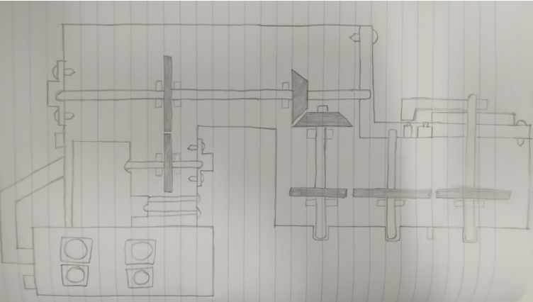

Figure 2: The final concept of assignment 1

The final concept od assignment 1 had the following issues:

* It could not bend the pipe fixed 40 mm the surface
* It could not bend the pipe in every direction
* The image of the concept was not clear enough
* The shaft support is not shown
* The angle control mechanism is not clear shown
* The concept did not the shape of the design into consideration

The new design is made using a drawing software so that the image are clear and every part can be seen. The following parts were redesigned:

* The housing
* The gearbox
* The battery holder
* The shaft supports
* The custom shaft

Battery holder

Housing

Shaft support

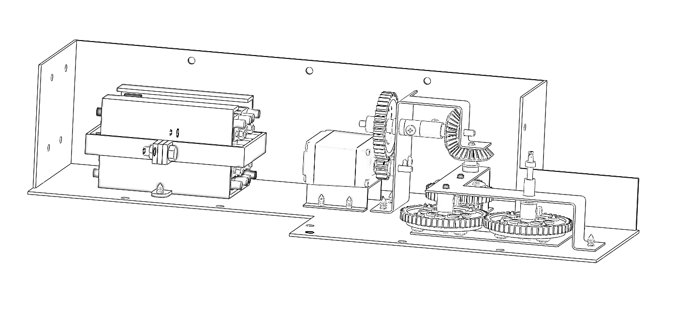

Figure 3: New concept gearbox

The top view of the new concept is attached below to show the position of all the internal parts

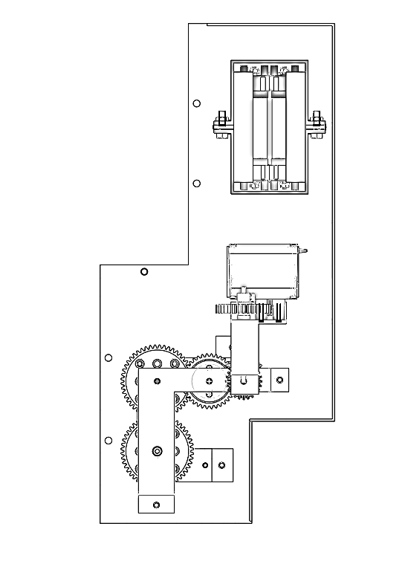

Figure 4: Top view of the new design

The shape of the housing because it has to allow the device to meet the following conditions:

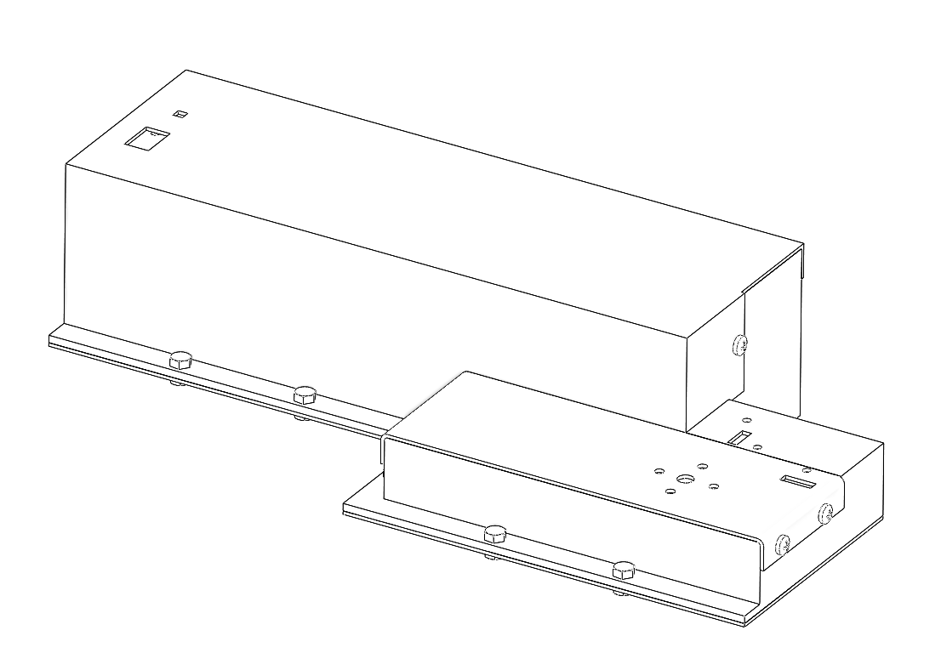

# Detail design description

## Motor mounting, shaft connection and gears alignment

The motor rest upon a 3D printed part named “motor lifter”, the motor lifter is secured to be casing using self-tapping screws. The motor lifter is used to provide adequate vertical space for the last 4 gears to fit in properly.

To properly located the motor, the mounting motor inserts are measured to be 4.6mm in diameter. The output socket for the shaft is measured to be 4.2mm in diameter.

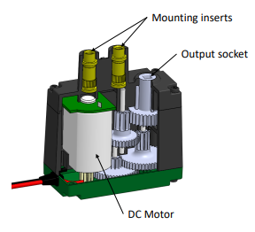

Figure 5: The inside of the motor

Thus, two 4.6mm diameter holes are cut into the motor support sheet metal to mount the motor. And a 4.2mm diameter hole is cut into the motor support sheet metal to support the shaft connecting to the motor.

The motor support is secured to the housing using self-tapping screws. The motor is mounted to the sheet metal using button head screws. The sheet metal is made with hot rolled mild steel. Thus, the button head screws together with the sheet metal part prevent the motor from moving.

The motor specification shows that it operates at low speeds. Therefore, the shafts can be simply supported through a sheet metal hole of 4.2mm in diameter.

Self-tapping screw

Motor lifter

Motor

Button head screw

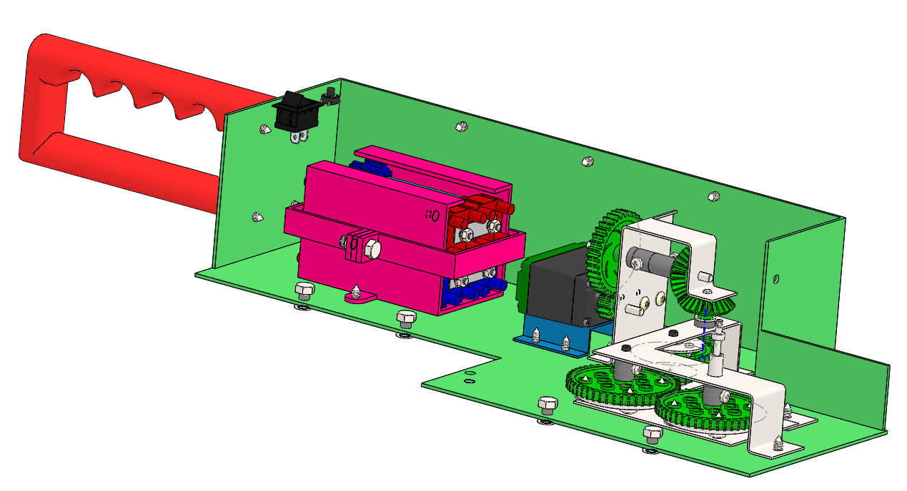

Figure 6: Motor mounting

The gearbox has 3 low carbon steel shafts, 2 high strength shaft and 1 custom shaft. So, in total there are 6 shafts. To properly align the shafts, the gears must be taken into considerations. The table below gives information about which gears are driven and which gears driving. It also shows which gears are on the same shaft. Each gear has its own colour, to make it easy to follow.

|  |  |  |  |
| --- | --- | --- | --- |
| Gears | Driven by | Drives | On the same shaft as |
| 12T spur gear | The motor | 36T spur gear | - |
| 36T spur gear | 12T spur gear | - | 24T bevel gear |
| 24T bevel gear | - | 24T bevel gear | 36T spur gear |
| 24T bevel gear | 24T bevel gear | - | 12T spur gear |
| 12T spur gear | - | 36T spur gear | 24T bevel gear |
| 36T spur gear | 12T spur gear | - | 24T spur gear |
| 24T spur gear | - | 48T spur gear | 36T spur gear |
| 48T spur gear | 24T spur gear | - | - |

The table below will be used to determine how the gears should be aligned. It shows the diameter of each gear.

|  |  |
| --- | --- |
| Gear | Diameter [mm] |
| 12 teeth spur gear | 12.7 |
| 24 teeth spur gear | 25.4 |
| 36 teeth spur gear | 38.1 |
| 48 teeth spur gear | 50.8 |
| 24 teeth bevel gear | 25.4 |

The first spur gear of 12 teeth connects to the first shaft. The 12 teeth spur gear meshes with the 36 teeth spur gear. The distance between the centres will be used to position the second shaft so that the two gears can mesh properly.

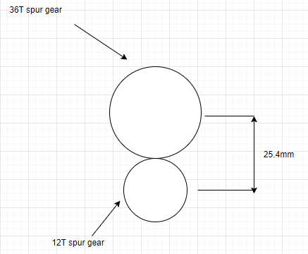

Figure 7: First meshing gears

The second shaft will be **25.4mm** above the first shaft.

The third gear is a 24 teeth bevel gear which is on the same shaft as the 36T spur gear. The third gear is meshing with another 24 teeth bevel gear. Therefore, a shaft needs to be correctly positioned to allow the gears to mesh properly.

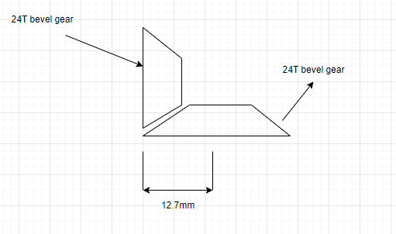

Figure 8: Second meshing gears

Therefore, the centre of the third shaft should be positioned **12.7mm** away from the edge of gear 3.

Gear 5 is a 12 teeth spur gear, and it is on the same shaft as gear 4. Gear 5 will mesh with gear 6 which is a 36 teeth spur gear. Therefore, a shaft needs to be correctly positioned to allow the gears to mesh properly.

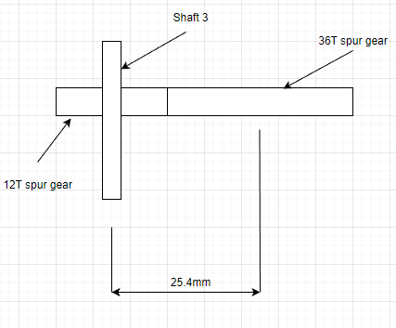

Figure 9: Third meshing gears

Therefore, the centre from shaft 3 to shaft 4 should be **25.4mm**.

Gear 7 is a 24 teeth spur gear, and it is on the same shaft as gear 6. Gear 7 will mesh with gear 8 which is a 48 teeth spur gear. Therefore, a shaft needs to be correctly positioned to allow the gears to mesh properly.

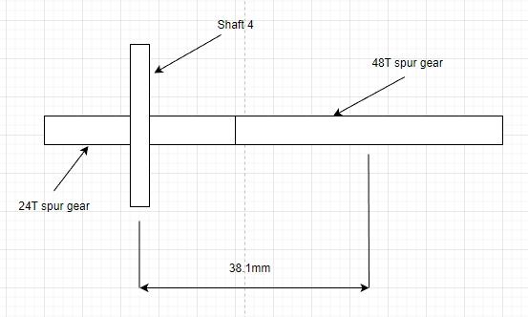

Figure 10: Fourth meshing gears

Therefore, the centre from shaft 4 to shaft 5 should be **38.1mm**.

Gear 8 is a 48 teeth spur gear and it will mesh with gear 9 which is a 48 teeth spur gear. Therefore, a shaft needs to be correctly positioned to allow the gears to mesh properly.

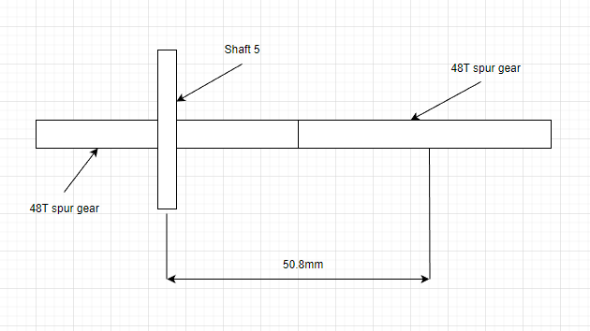

Figure 11: Fifth meshing gears

Therefore, the centre from shaft 4 to shaft 5 should be **38.1mm**.

To ensure that the shafts will not move, sheet metal support component are included in the design to hold them in place. The spacers and washers will be used to ensure that the gears are always aligned. This can be in the figure below.

Spacer

Lower shaft support

Motor support

Upper shaft support

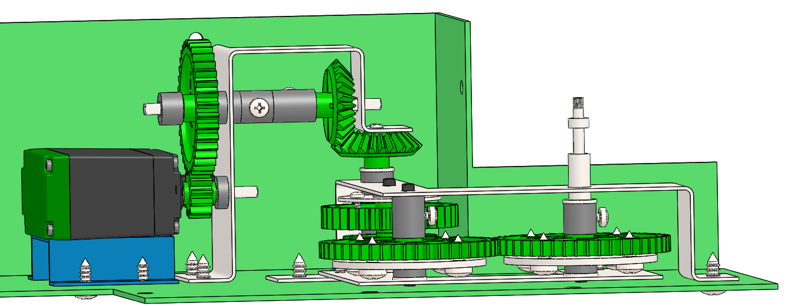

Figure 12: Spacers, washers and supports

## Force/torque transfer and shaft/s support with related strength and deflections

Strengthening

The motor transfers torque to the first gear through a shaft. The torque experienced by each gear is determined (**See the detail calculation in Appendix B**). The torque that each gear will experience is then compared to its maximum allowable torque. Here’s a table below showing the calculation results.

|  |  |  |  |
| --- | --- | --- | --- |
|  | Maximum Torque [Nm] | Experienced  Torque [Nm] | Rotational speed [rad/s] |
| Gear 1 [12T] | 3 | 0.941 | 14.537 |
| Gear 2 [36T] | 3.4 | 2.627 | 4.508 |
| Gear 3 [24T] | 3 | 2.627 | 4.508 |
| Gear 4 [24T] | 3 | 2.489 | 4.272 |
| Gear 5 [12T] | 3 | 2.489 | 4.272 |
| Gear 6 [36T] | 3.4 | 6.946 | 1.324 |
| Gear 7 [24T] | 1 | 6.946 | 1.324 |
| Gear 8 [48T] | 1.2 | 13.269 | 0.638 |
| Gear 9 [48T] | 1.2 | 12.922 | 0.621 |

The above table shows that Gear 6, 7, 8 and 9 have to reinforced because the torque that they will experience is greater than its maximum allowable torque. The figure below shows how the gears should be reinforced.

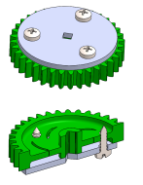

Figure 13: Reinforced gears

Thus, a doubler-plate cut from sheet metal to one side of the gear, and fastened with self-tapping screws will be used to reinforce the gear. The double plate thickness is determined using the method below.

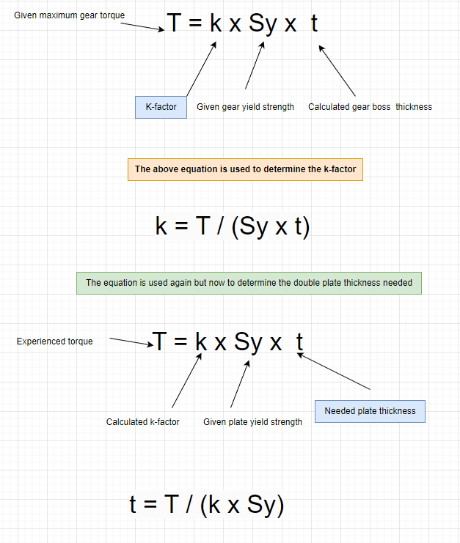

Figure 14: Method for double plate thickness approximation

The following results from **Appendix F**, show how much thickness is needed for each double plate.

|  |  |  |  |
| --- | --- | --- | --- |
|  | Maximum torque [Nm] | Experienced torque [Nm] | Plate thickness needed [mm] |
| Gear 6 [36T] | 3.4 | 6.946 | 0.712 |
| Gear 7 [24T] | 1 | 6.946 | 0.958 |
| Gear 8 [48T] | 1.2 | 13.269 | 1.659 |
| Gear 9 [48T] | 1.2 | 12.922 | 1.615 |

The figure below show how the double plates are used to support the gears, taking into account the minimum thickness they need.

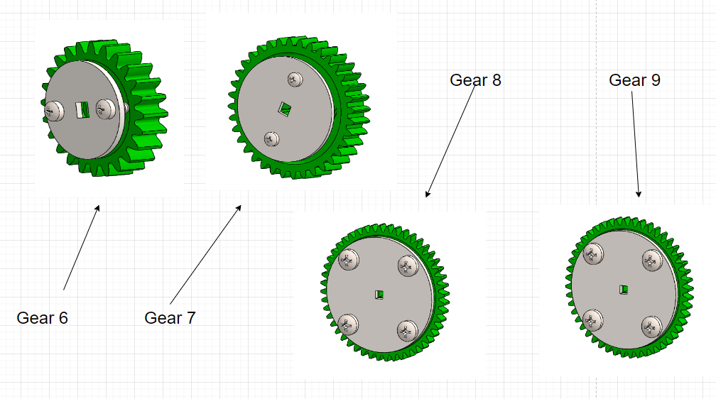

Figure 15: Reinforced gears

Each gear will have a tangential and force due meshing. The following equations are used to determine the different forces.

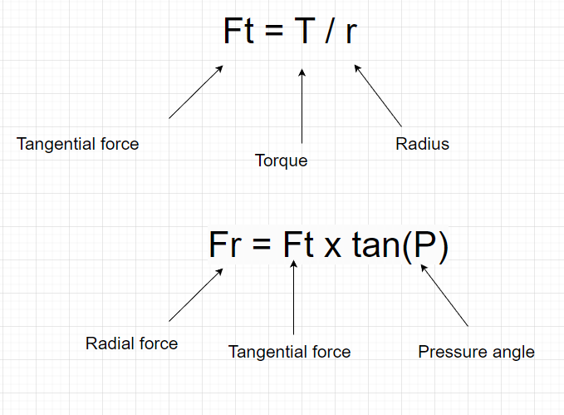

Figure 16: Forces equation

The following figure shows an example of gear 1 calculations from **Appendix C.**

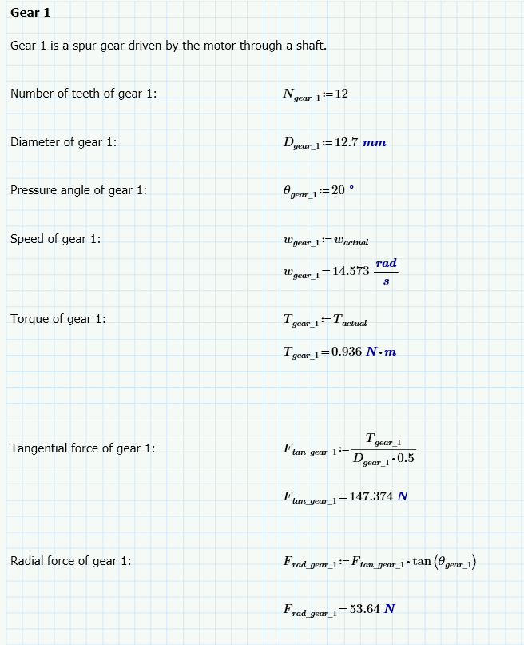

Figure 17: Gear 1 calculations

The rest of the calculations are in **appendix C.** The table below shows a summary of the calculations.

|  |  |  |  |
| --- | --- | --- | --- |
|  | Maximum tangential force [N] | Experienced tangential force [N] | Experienced radial force [N] |
| Gear 1 [12T] | 450 | 148.228 | 53.95 |
| Gear 2 [36T] | 700 | 137.879 | 50.184 |
| Gear 3 [24T] | 300 | 206.819 | 75.276 |
| Gear 4 [24T] | 300 | 195.99 | 71.335 |
| Gear 5 [12T] | 450 | 391.98 | 142.669 |
| Gear 6 [36T] | 700 | 364 | 132.709 |
| Gear 7 [24T] | 580 | 546.923 | 199.064 |
| Gear 8 [48T] | 580 | 522.417 | 190.144 |
| Gear 9 [48T] | 580 | 508.74 | 185.166 |

The table above shows the forces that will be exerted by each gear. Therefore, the forces are going to act on the gears. So, the deflection each shaft has to be determined to ensure that it won’t deflect to such a point that it affects gear alignment and meshing.

The following method will be used to determine the deflection of gears.

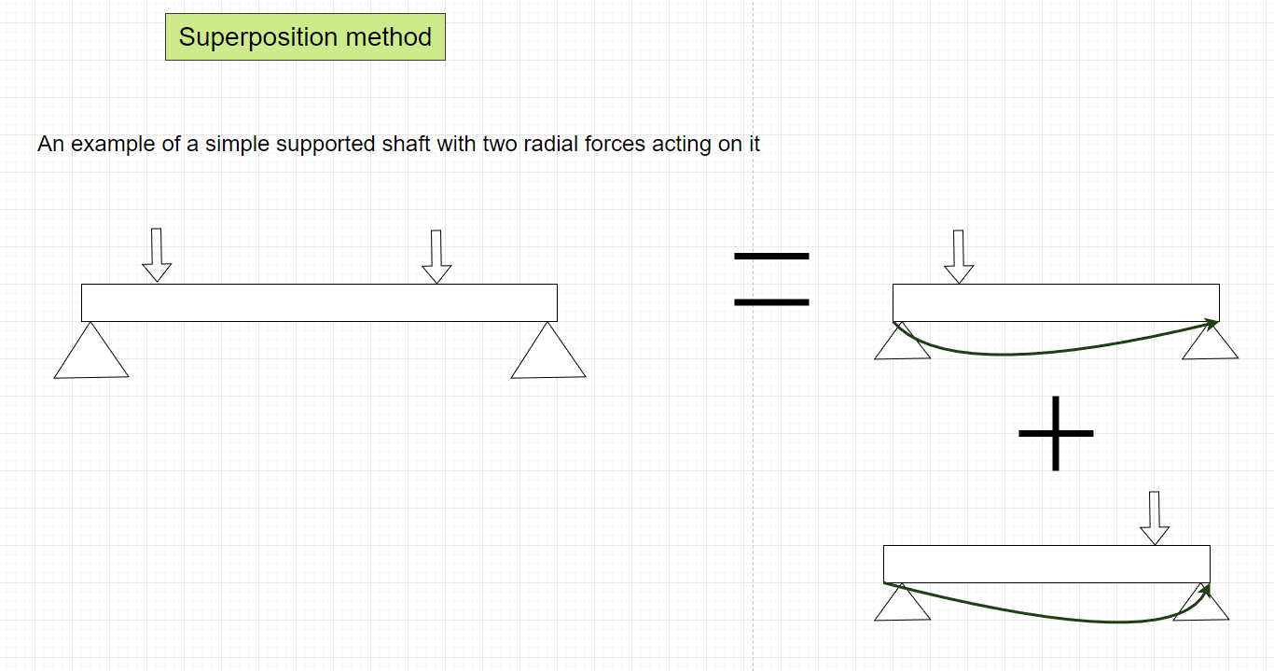

Figure 18: Superposition method

The above figure shows that the superposition method used will evaluate the deflection caused by each gear force at point of interest. Then the resulted deflection will be calculated by just adding the deflection caused by each force at a point of interest. The point of interest will be where the gears are meshing / the forces are acting.

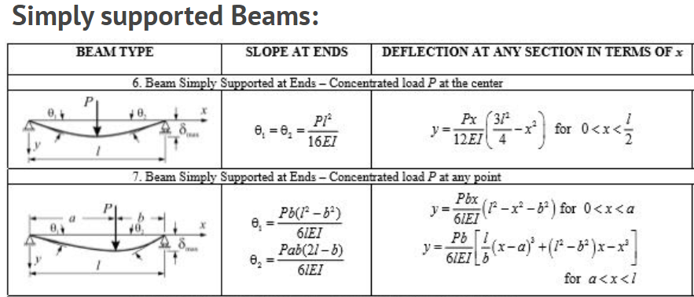

Figure 19: Deflection of beams equations

The above equation is from Mechanics of material textbook [1]

The figure below shows the deflection direction due to each for force

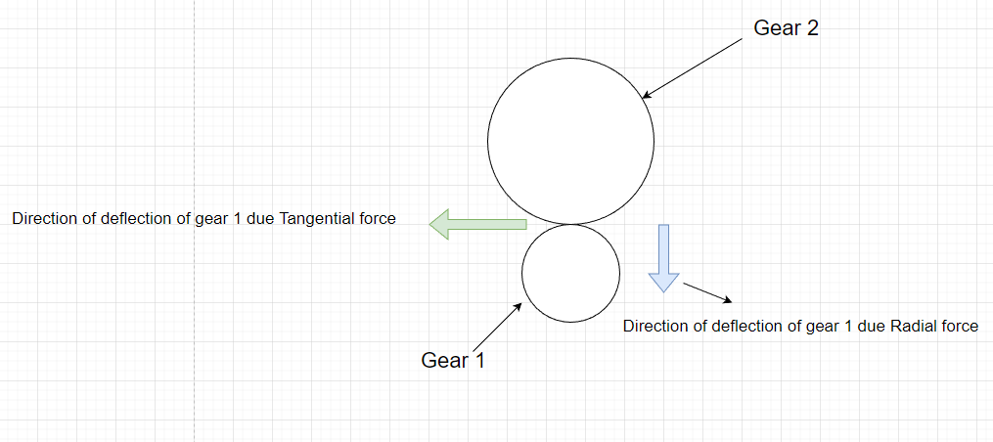

The results from the deflection calculations in **Appendix D** is the following.

|  |  |  |  |  |
| --- | --- | --- | --- | --- |
| Shafts | First point of interest | | Second point of interest | |
| Deflection due to radial forces [mm] | Deflection due to tangential forces [mm] | Deflection due to radial forces [mm] | Deflection due to tangential forces [mm] |
| Shaft 1 | 0.047 | 0.017 | - | - |
| Shaft 2 | 0.196 | 0.537 | 0.162 | 0.446 |
| Shaft 3 | 0.103 | 0.282 | 0.189 | 0.519 |
| Shaft 4 | 0.089 | 0.0246 | 0.089 | 0.246 |
| Shaft 5 | 0.056 | 0.153 | - | - |
| Shaft 6 | 0.151 | 0.415 | - | - |

The above table shows the deflection caused by the radial forces and tangential forces at each point of interest.

The deflection values in the above table are too small to affect the gear alignment and meshing. Therefore, the shafts are strong enough to not get negatively affected by deflection.

Torsion

The effect of torsion on each should be determined. The torque that each shaft experiences is calculated in **Appendix B**. The results are in the table below.

|  |  |
| --- | --- |
| Shafts | Torque experienced [Nm] |
| Shaft 1 | 0.941 |
| Shaft 2 | 2.627 |
| Shaft 3 | 2.489 |
| Shaft 4 | 6.946 |
| Shaft 5 | 13.269 |
| Shaft 6 | 12.922 |

Therefore, using the above table, the shear stress applied to each shaft can be determined. It can then be compared to the shaft’s shear strength and yield strength. The detail calculations are **Appendix D**. The results of the calculation are in the table below.

|  |  |  |  |
| --- | --- | --- | --- |
| Shaft | Shear stress experience [GPa] | Shear strength [GPa] | Yield strength [MPa] |
| Shaft 1 | 0.702 | 3.732 | 450 |
| Shaft 2 | 1.961 | 3.732 | 450 |
| Shaft 3 | 1.858 | 3.732 | 450 |
| Shaft 4 | 5.184 | 3.732 | 450 |
| Shaft 5 | 9.903 | 3.732 | 450 |
| Shaft 6 | 9.644 | 3.732 | 450 |

The above table show that each shaft will not fail due shear stress because the shear stress it is experiencing is less than the shaft shear strength and yield strength.

Component packaging

The components should in the following way:

* The electronics such as switches and wires should have its own package.
* The fasteners such as self-tapping screws and bolts should have its own package.
* The 3D printed parts and gears should have its own package.
* The sheet metal parts should have its own package.
* The machined parts should have its own package.

## Gearbox / mechanical advantage device design with strength and efficiency considerations

The gearbox is designed in such a way that it will be able to output enough torque to bend the pipe. Therefore, the required bending moment need to bend the pipe has to be determined. In Appendix A, it was determined to be **12.922Nm**.

Now the correct motor must be selected before the gearbox is designed. The motor will be selected based on the following criteria:

* Peak current
* Peak output torque
* Peak output speed
* Peak trip time

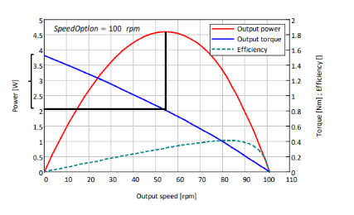

Figure 20: Graph from motor specification document

In order to determine the peak motor current, stall torque has to be used. The above figure shows that the motor will approximately have peak current at half the stall torque.

The stall torque is calculated using the equation below.



Figure 21: Output torque formula

Thus, now the peak current, output torque, output speed and trip time can be determined. (See detail calculations in **Appendix B**) The results of the calculations are in the table below.

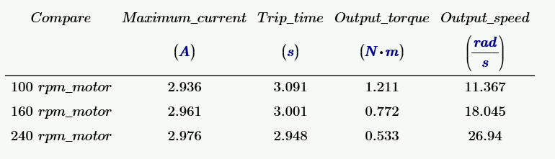

Figure 22: Summary of results

Thus, for this design the **100rpm motor** will be used because it has the largest output torque and longest trip time.

Largest output torque allows one to design the gearbox with a low gear ratio. Longest trip time gives the design more time to achieve the goal before it stops working.

Now the required gear train ratio for the gearbox can be calculated based on the required bending moment and the peak output motor torque.

The required gear train ratio was determined to be **10.671 (in Appendix C)**.

The gearbox has to be designed that will meet the required gear ratio of 10.671. Through trial and error, a gearbox was designed that will provided a gear train ratio that is larger than the required gear ratio. Here’s a table below showing how the gearbox is designed.

|  |  |  |  |
| --- | --- | --- | --- |
| Gears | Driven by | Drives | On the same shaft as |
| 12T spur gear | The motor | 36T spur gear | - |
| 36T spur gear | 12T spur gear | - | 24T bevel gear |
| 24T bevel gear | - | 24T bevel gear | 36T spur gear |
| 24T bevel gear | 24T bevel gear | - | 12T spur gear |
| 12T spur gear | - | 36T spur gear | 24T bevel gear |
| 36T spur gear | 12T spur gear | - | 24T spur gear |
| 24T spur gear | - | 48T spur gear | 36T spur gear |
| 48T spur gear | 24T spur gear | - | - |

The gear train efficiency has to be determined based on the number of meshing gears. The equation below will be used to determine the efficiency.

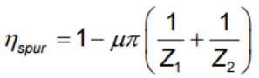

Figure 23: Efficiency equation

Here’s a table below showing which gears are meshing.

|  |  |
| --- | --- |
|  | Meshing gears |
| Mesh 1 | 12T spur gear with 36T spur gear |
| Mesh 2 | 24T bevel gear with 24T bevel gear |
| Mesh 3 | 12T spur gear with 36T spur gear |
| Mesh 4 | 24T spur gear with 48T spur gear |
| Mesh 5 | 48T spur gear with 48T spur gear |

The efficiency for each meshing gear is determined. The gear train efficiency is determined by multiplying all the 5 meshing gears efficiencies, this resulted in a gear train efficiency of **0.767**.

Therefore, the gear ratio including the gear train efficiency was determined to be **13.808**. This is greater than the required gear train efficiency of 10.671.

Now the following has to be determined using the actual gear train ratio:

* Motor operating current
* Motor output torque
* Motor output speed
* Motor trip time

The operating output torque is determined by dividing the required bending moment with the actual gear train ratio. Here’s a table showing the results of operating conditions in comparison to the peak condition.

|  |  |  |
| --- | --- | --- |
|  | **Peak condition** | **Actual condition** |
| **Current [A]** | 2.936 | 1.847 |
| **Output speed [rad/s]** | 11.367 | 14.537 |
| **Output torque [Nm]** | 1.211 | 0.941 |
| **Trip time [s]** | 3.091 | 15.948 |

The gearbox mechanical advantage is the gear train ratio **13.808.**

The strength and the forces of gears is determined in **section 2.2** above this.



Figure 24: Gearbox design with all the parts in place

## Final actuator design, clearly showing pipe support and operation.

The URS state that the device shall bend the pipe to an inner radius of 15mm without pinching. Thus, a big roller of inside 15mm will be used to provided surface that the will around.

A custom shaft is made for the last gear that will drive the actuator. It is made using the following components:

* 30mm high strength shaft
* Shaft coupler
* Custom circular shaft

The 30mm high strength shaft will merge with the custom circular shaft using a shaft coupler in between, they will be soldered onto the shaft coupler. The figure below shows how the custom shaft should look.

Custom circular shaft

Shaft coupler

High strength shaft

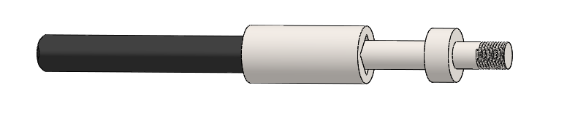

Figure 25: Custom shaft

The bending die that will get in contact with die will be machined. It will be designed like the figure below.

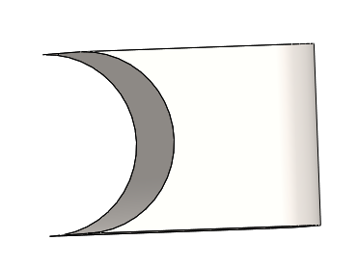

Figure 26: Bending die

The platform for the bending die to sit on has to be designed in such a way that it will also provide the platform for the angle control mechanism.

Considering that it will be machined using a CNC machine, it shows also allow a 3mm ball nose mill to be able to craft. The figure below shows how the bending platform is made.

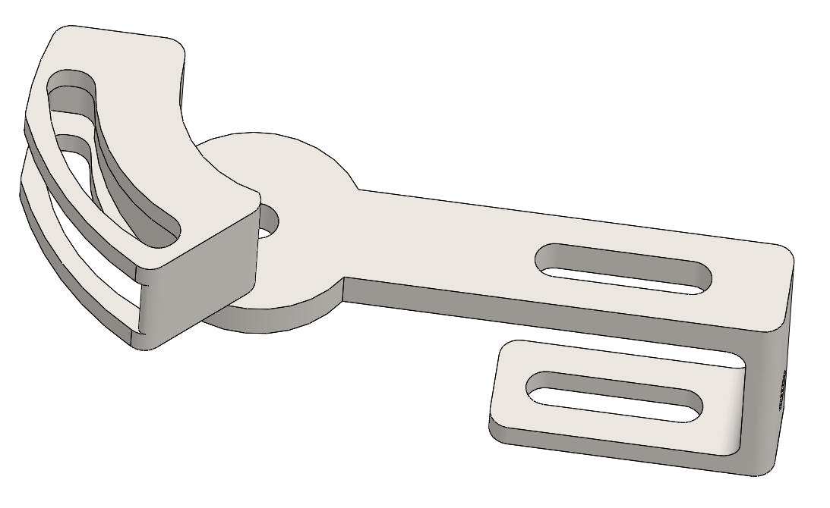

Figure 27: Bending platform

Now the following parts needed to be designed:

* Bending die position (To allow the bending die to move to a specific position
* Clamp (To clamp the bending die to a pipe)
* The angle lock (Will be used for angle control mechanism)
* Angle positioner (To set the angle)

The figure below shows how the final actuator design looks.

Clamp

Bending die

Positioner

Platform

Angle lock

Angle positioner

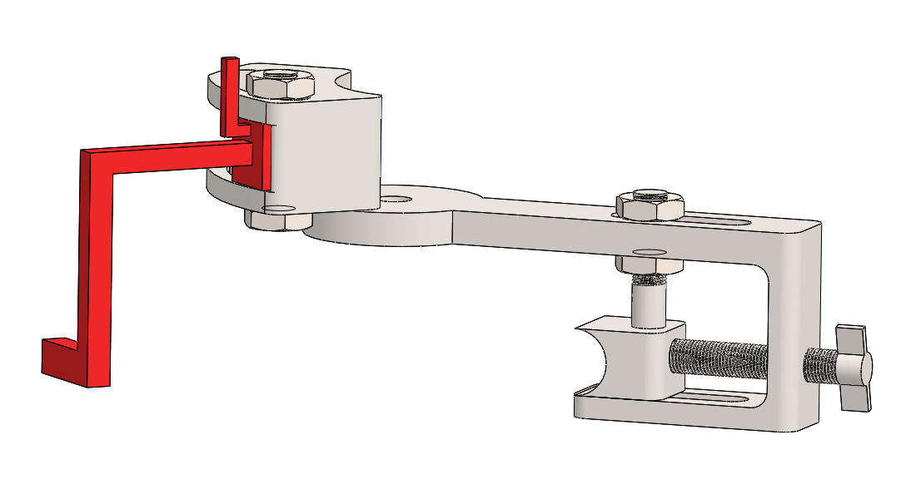

Figure 28: Actuator design

The custom shaft is designed in such a way that the actuator will not be in contact with the big roller and the base to avoid the frictional forces. This can be seen in the figure below.

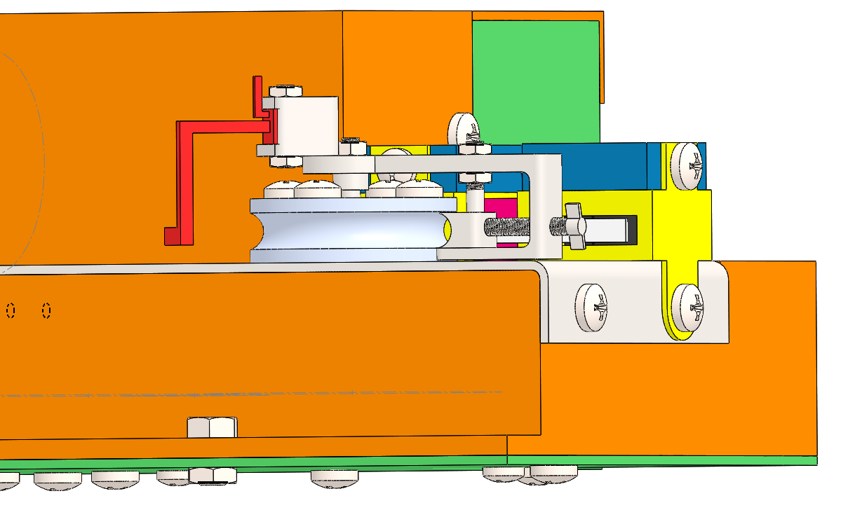

Figure 29: Model showing the actuator, big roller and base

The component that will support the pipe as it is getting bend has to designed. It must be considered that a pipe of 6mm diameter will be bent (state the URS). The figure below shows the pipe support design.

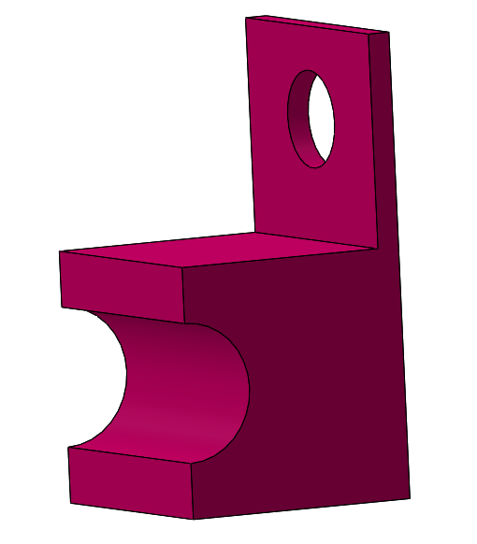

Figure 30: pipe support

Operation

The following figures show the model will work it is bent by doing the following:

* Clamping the pipe tight between the big roller and the bending
* Support the pipe.

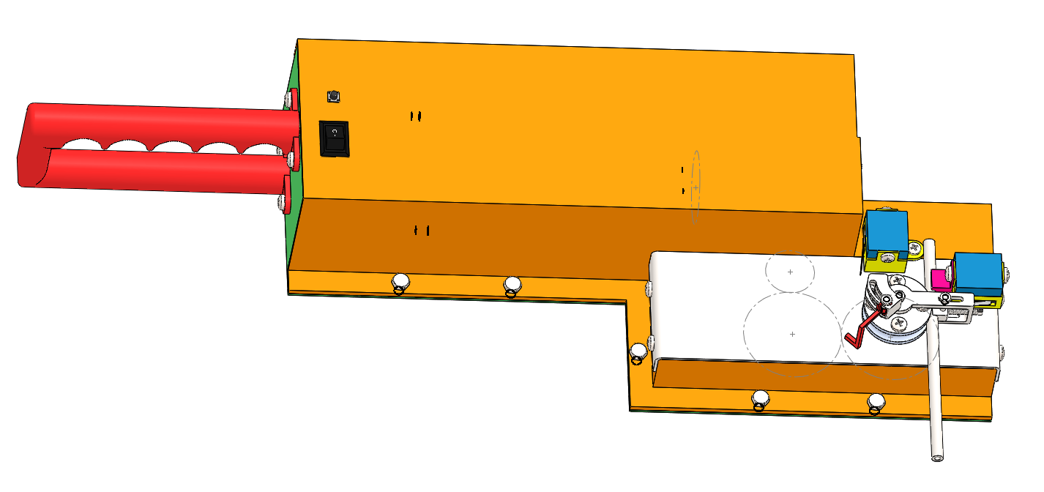

Figure 31: Pipe in operation

## Angle control mechanism design and functionality

The angle control mechanism needs the following components:

* Microswitches for stopping the actuator at a certain point
* Push switch to start the motor rotation
* Control switch to change rotational direction of the motor.

The microswitch that will be used is in the figure below:

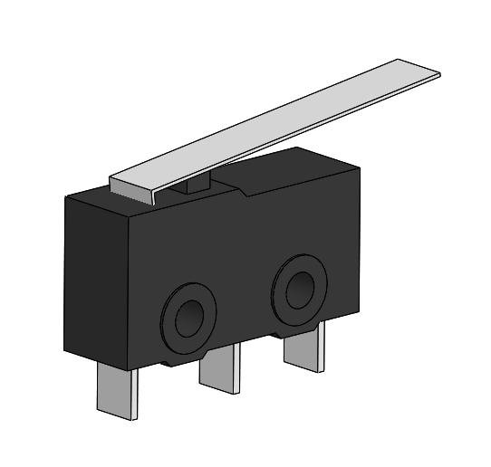

Figure 32: Microswitch

The push button that will be used is in the figure below:

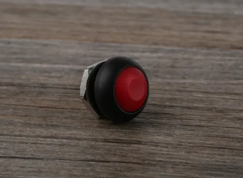

Figure 33: Push button from RS components (RS Components, 2023)

The control switch that will be used is in the figure below:

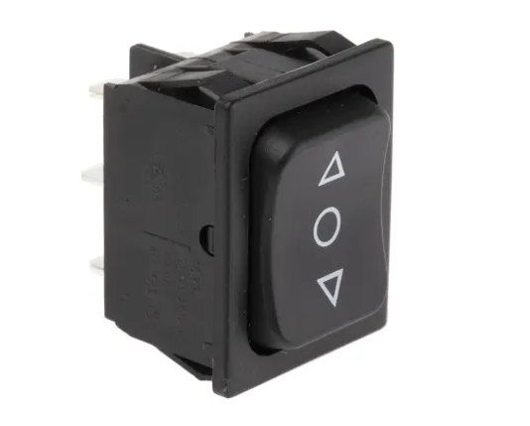

Figure 34: Control switch from RS components (RS components, 2023)

This is how the angle control should work:

* The first limit microswitch will stop the actuator at a desired angle
* The second microswitch will stop the actuator at the starting position
* The push switch will start the motor
* The control switch will the rotational direction of the motor

Set the angle



The highlighted part in the above figure will be used to set the desired angle and it will also trigger the limit switch.

In the event that the user will want to bend the pipe to an angle of 90 degrees, here are the steps that should be followed:

# Move the angle positioner to the desired angle, this is shown in the figure below

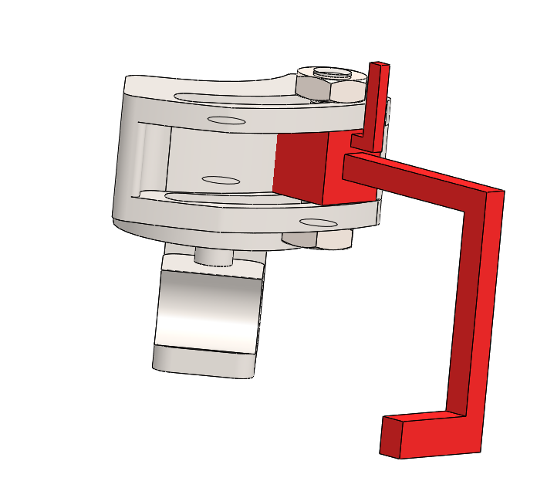

Figure 35: Moving the angle positioner to the very end will give an angle of 90 degrees

* The user will then hit the push button
* The actuator will rotate until it hits the limit switch, this can be seen in the figure below

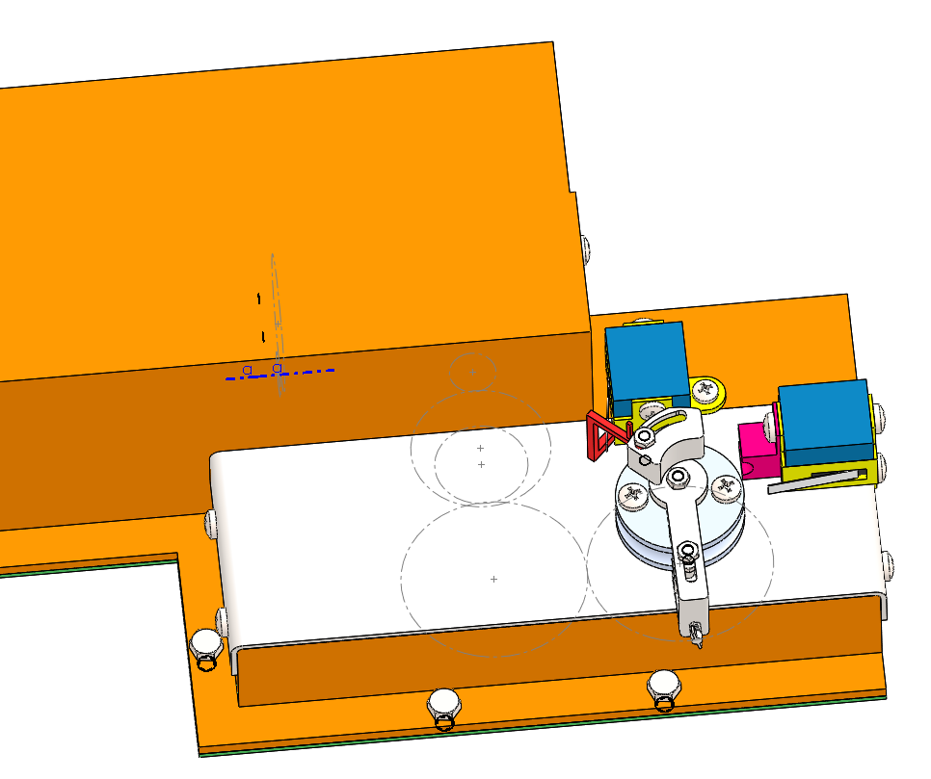

Figure 36: Actuator stopped at 90 degrees

* The user will then hit the control switch to change the rotational direction of the motor
* After, the user will press the push button to allow the actuator to rotate in a reverse direction
* The actuator will reverse until it hits the limit switch at the starting position, this ca be seen in the figure below

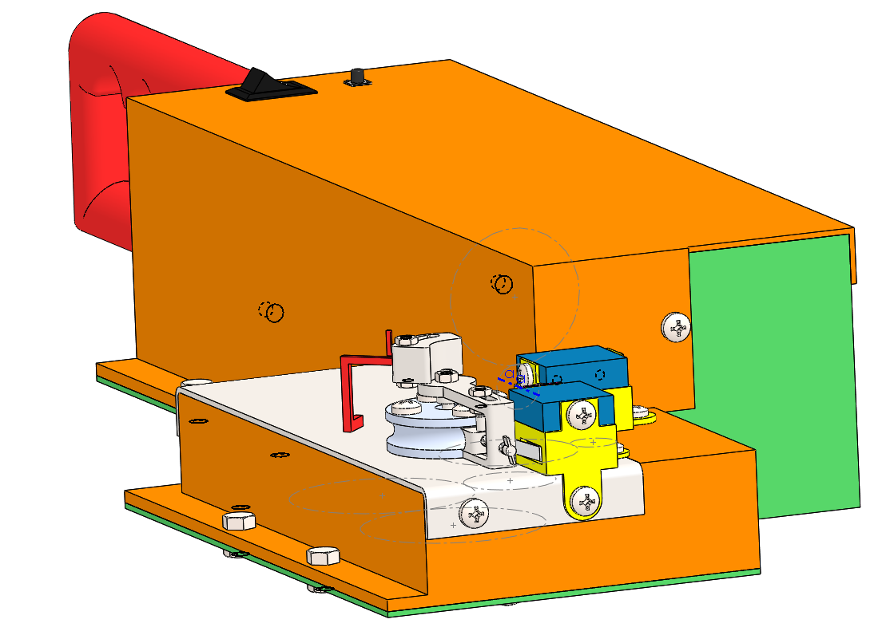

Figure 37: Actuator triggers the limit switch at the starting position

The figure below shows the position of all the switches.

Limit switch

Limit switch

Push button

Control switch

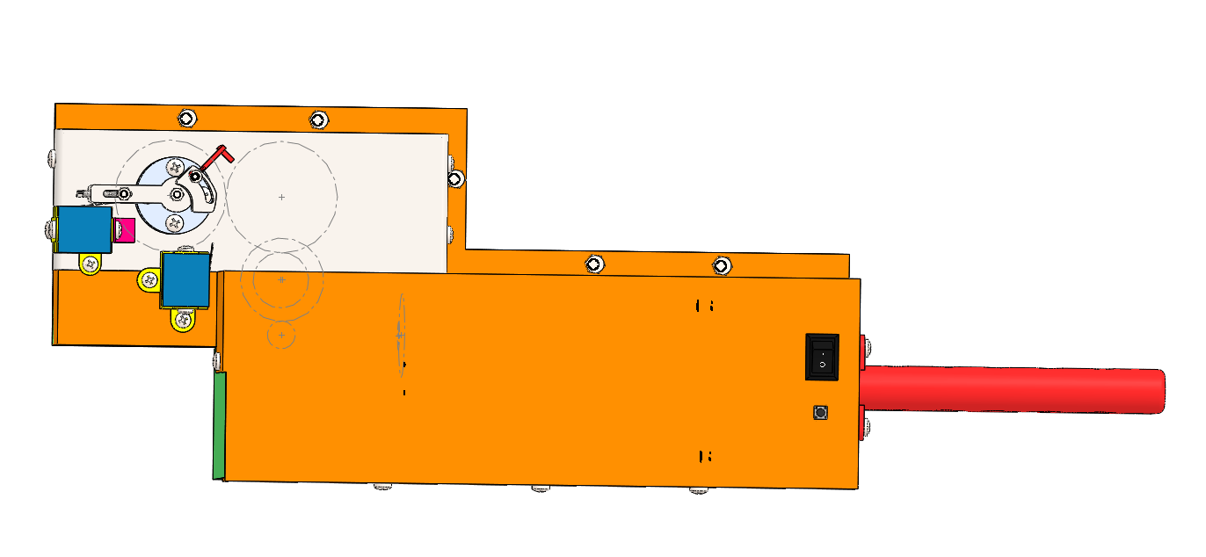

## Component packaging, manufacturing/assembly considerations and ergonomics considerations

Material selection

The parts that are not providing any support do not need to be strong will be 3D printed using PLA plastic.

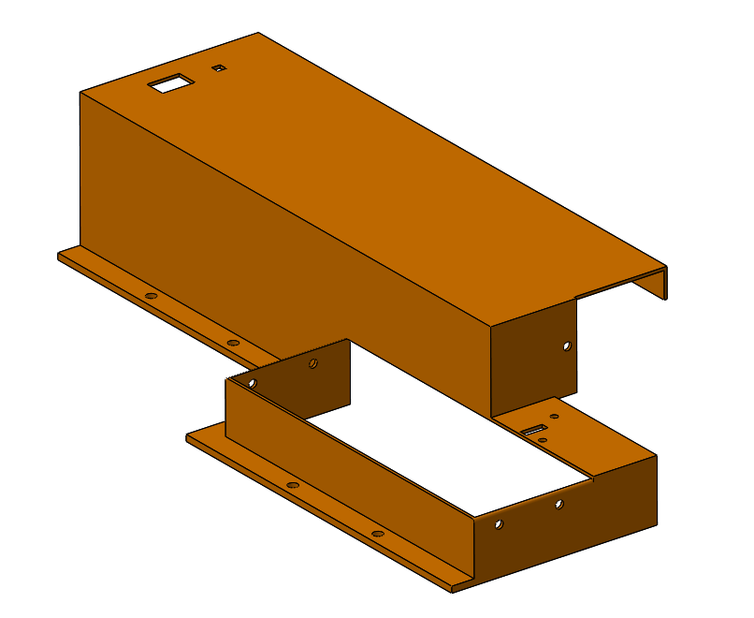

Figure 38: Example of a 3D printed part

The parts that will be providing support will be manufactured using hot rolled sheet metal.

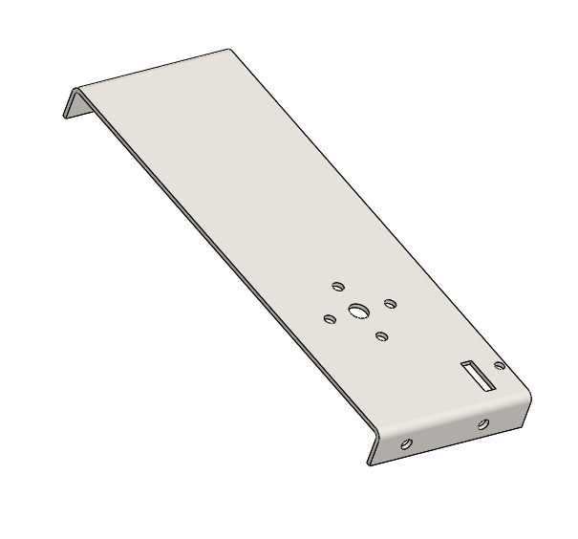

Figure 39: Example of a sheet metal part

The important that are involved in bending the pipe need to be machine using low carbon.



Figure 40: Example of a machined part

Assembly considerations

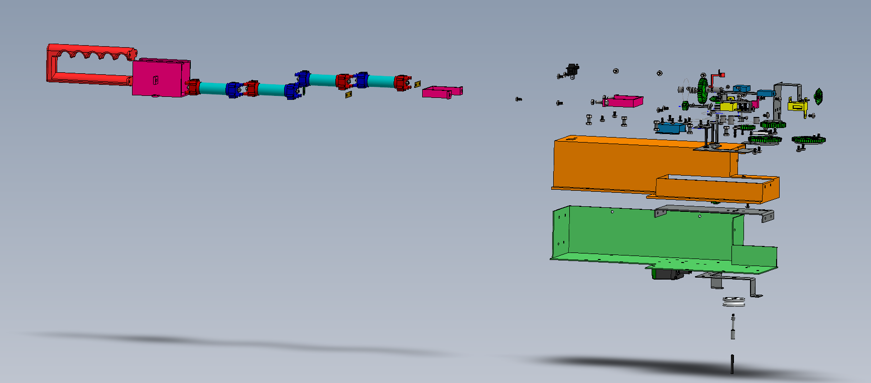

Figure 41: Exploded view showing all the parts.

The above figure shows all the parts that need to be assembled to form a complete model. The lower housing is designed particularly to allow all the internal the assemble without a problem.

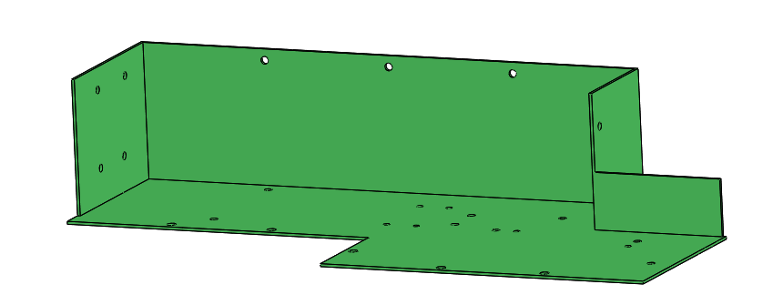

Figure 42: Lower housing

Before the upper housing is mounted on the lower housing. The wires must be passed through its holes on the upper housing to ensure that the switches and the motor can be connected.

Then the upper housing can be mounted to the lower housing using nuts, bolts, and self-tapping screws.

The upper housing is designed in such a way that it leaves spaces for where the bending base will sit. It also allows all the internal parts to assembled first before the external parts are assembled.

The bending base which is a sheet metal will be mounted on the upper housing using self-tapping screws.

Then the external parts can be assembled and mounted onto the bending base. After that the wiring can be done, which is exposed to the outside.

Ergonomics consideration

The handle is designed in such a way that it can be held with one hand, and it does not have any sharp edges. Thus, it will not damage the user when it being used.

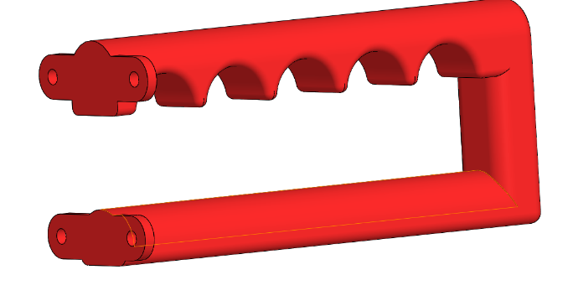

Figure 43: Handle

The machined bending platform part is designed in such a way that it will allow a 3mm ball nose mill to fit through all the holes. It does have any sharp edges that the ball nose mill won’t be able to make.

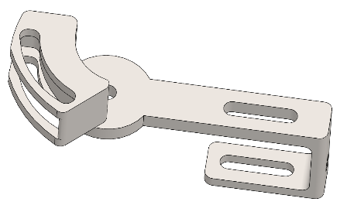

Figure 44: Bending platform

The handle and two switches (control switch and push switch) are very close to each other to allow for one hand operation.

The two switches are also close to the battery and motor to allow for easy wiring.

There’s enough space inside the model to allow the wires to go to the microswitches in front without interfering with the internal parts.

The housing shape is designed to allow the pipe to fully bend without interfering with any external parts.

# BOM costing with prototype and production cost

Mass calculations

The mass of the parts that will be bought (e.g. Motor, switches) is given by the supplier and does not need to be calculated.

The mass of custom parts that need to be manufactured is determined in the following way:

Mass = Density x Volume

Density of the following materials is used for calculations:

* 3D printed components – PLA plastic
* Sheet metal components – Hot rolled mild steel
* Machined components – Low carbon steel

The volume used is calculated using solidworks, which is accurate for complex components.

Here’s an example of the mass calculation.

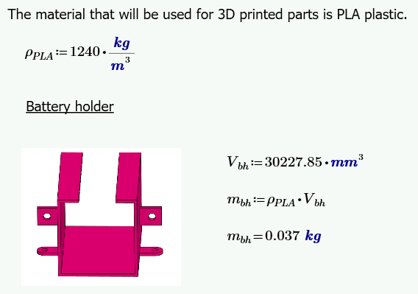

Figure 45: Example of mass calculation

The rest of the mass calculations are in **Appendix G**.

Cost calculations

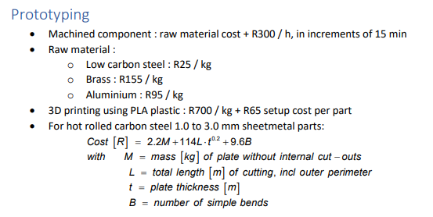

Figure 46: Typical costing inputs

The above typical costing inputs are used to determine the costs of all the components.

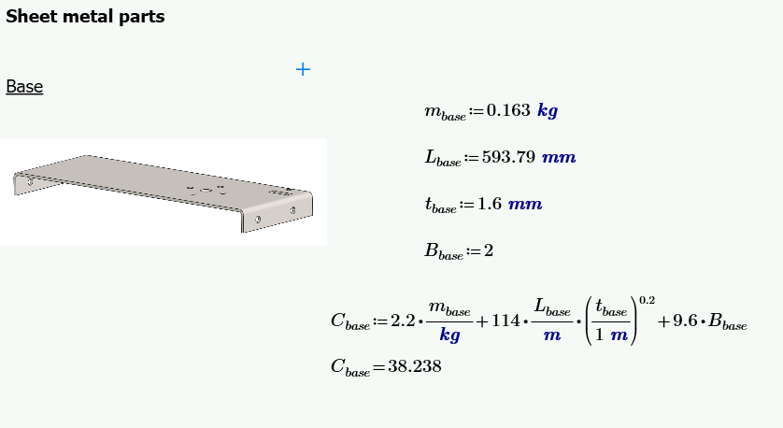

Figure 47: Example of cost calculations

The above figure shows an example of how cost will be determined using the inputs in Figure 5. The detail cost calculations are in **Appendix G**.

Here’s a bill of material below, showing the cost and mass of each component

|  |  |  |  |  |  |  |
| --- | --- | --- | --- | --- | --- | --- |
| **NO.** | **PART NUMBER** | **DESRIPTION** | **SPECIFICATION** | **MASS**  **[kg]** | **COST**  **[rands]** | **QTY** |
| 1 | MEC4124-004-30 | SQ shaft 30 long | Square Shaft 0.125" x 30mm (VEX 276-1149) | 0.002 | 4.8 | 1 |
| 2 | MEC4124-010 | 12T Gear | 12T spur gear, 24/"P (VEX 276-2169-001) | 0.002 | 9 | 2 |
| 3 | MEC4124-004-70 | SQ shaft 70 long | Square Shaft 0.125" x 70mm (VEX 276-1149) | 0.005 | 11.2 | 1 |
| 4 | MEC4124-016 | 24T Bevel Gear | 24T bevel gear, 24/"P (VEX 276-2184-001) | 0.002 | 12 | 2 |
| 5 | MEC4124-004-45 | SQ shaft 45 long | Square Shaft 0.125" x 70mm (VEX 276-1149) | 0.003 | 7.2 | 1 |
| 6 | MEC4124-001 | 100rpm Motor | 2-Wire Motor 393 (VEX 276-2177) | 0.09 | 315 | 1 |
| 7 | MFKKAT007-001 | Motor lifter | See DWG for details, PLA 3D printed | 0.003 | 67.1 | 1 |
| 8 | MFKKAT007-002 | Battery holder | See DWG for details, PLA 3D printed | 0.037 | 90.9 | 1 |
| 9 | MEC4124-030 | Cell w caps | Li-ion LFP 18650 cell with Vruzend connector caps | 0.216 | 216 | 4 |
| 10 | MEC4124-031 | Cell link | 0.5mm Plated Brass link (Vruzend) | 0.002 | 2 | 2 |
| 11 | MEC4124-032 | Fused link | PCB with 5A resettable fuse | 0.0015 | 25 | 1 |
| 12 | MEC4124-008-30 | HS SQ shaft 30 long | Square Shaft 0.125" x 30mm, heat treated (VEX 276-1149) | 0.007 | 14.4 | 2 |
| 13 | MFKKAT007-003 | Lower Housing | See DWG for details, PLA 3D printed | 0.16 | 177 | 1 |
| 14 | MFKKAT007-004 | Upper Housing | See DWG for details, PLA 3D printed | 0.149 | 169.3 | 1 |
| 15 | MFKKAT007-005 | Base | See DWG for details, 1.6mm Hot Rolled Mild Steel | 0.163 | 38.24 | 1 |
| 16 | MEC4124-052 | Big Roller | 30mm roller, 6.5dia groove | 0.065 | 65 | 1 |
| 17 | MFKKAT007-006 | Microswitch lower holder two | See DWG for details, PLA 3D printed | 0.004 | 67.8 | 1 |
| 18 | MFKKAT007-007 | Microswitch Lower Holder | See DWG for details, PLA 3D printed | 0.004 | 67.8 | 1 |
| 19 | MEC4124-036 | Microswitch | Sub-Miniature Micro Switch 1C-SPDT(CO), 5A, 250VAC (Comm SS5GL111) | 0.004 | 34 | 2 |
| 20 | MFKKAT007-008 | Motor Support | See DWG for details, 1mm Hot Rolled Mild Steel | 0.037 | 57.85 | 1 |
| 21 | MFKKAT007-009 | Upper Shaft Support | See DWG for details, 1mm Hot Rolled Mild Steel | 0.041 | 50.72 | 1 |
| 22 | MFKKAT007-010 | Lower Shaft Support | See DWG for details, 1mm Hot Rolled Mild Steel | 0.034 | 13.79 | 1 |
| 23 | MFKKAT007-011 | Handle | See DWG for details, PLA 3D printed | 0.097 | 132.9 | 1 |
| 24 | MFKKAT007-012 | Double plate for 48T gear | See DWG for details, 2mm Hot Rolled Mild Steel | 0.049 | 6.91 | 2 |
| 25 | MEC4124-013 | 48T Gear | 48T spur gear, 24/"P (VEX 228-3450-228) | 0.0002 | 18 | 2 |
| 26 | UCT-19516 | Self-tapping screw | DIN 7049 ST4.2 X 9.5, Carbon  Steel Gr 8.8 | 0.0004 | 4 | 4 |
| 27 | MFKKAT007-013 | Modified 36T Gear | Modified 36T gear MEC4124-012 see DWG for details | 0.0052 | 36 | 1 |
| 28 | MFKKAT007-014 | Double plate for 36T gear | See DWG for details, 1mm Hot Rolled Mild Steel | 0.006 | 3.47 | 1 |
| 29 | UCT-19502 | Self-tapping screw | DIN 7049 ST2.2 X 9.5, Carbon  Steel Gr 8.8 | 0.002 | 2 | 2 |
| 30 | MFKKAT007-015 | Modified 24T Gear | Modified 24T gear MEC4124-011 see DWG for details | 0.002 | 12 | 1 |
| 31 | MFKKAT007-016 | Double plate for 24T gear | See DWG for details, 1mm Hot Rolled Mild Steel | 0.0025 | 3.46 | 1 |
| 32 | UCT-19501 | Self-tapping screw | DIN 7049 ST2.2 X 6.5, Carbon  Steel Gr 8.8 | 0.0001 | 2 | 2 |
| 33 | MEC4124-008-30 | HS SQ shaft 30 long | Square Shaft 0.125" x 30mm, heat treated (VEX 276-1149) | 0.007 | 14.4 | 1 |
| 34 | MEC4124-007 | Shaft Coupler | Shaft Coupler (VEX 276-1843-001) | 0.003 | 25.5 | 1 |
| 35 | MFKKAT007-017 | Custom circular shaft | See DWG for details, Low Carbon Steel | 0.002 | 150.05 | 1 |
| 36 | MFKKAT007-018 | Clamp platform | See DWG for details, Low Carbon Steel | 0.024 | 450.6 | 1 |
| 37 | MFKKAT007-019 | Bending Die | See DWG for details, Low Carbon Steel | 0.002 | 75.05 | 1 |
| 38 | MFKKAT007-020 | Die positioner | See DWG for details, Low Carbon Steel | 0.00089 | 75.02 | 1 |
| 39 | MFKKAT007-021 | Die lock | See DWG for details, Low Carbon Steel | 0.00096 | 150.024 |  |
| 40 | MFKKAT007-022 | Angle lock | See DWG for details, PLA 3D printed | 0.00051 | 65.36 | 1 |
| 41 | MFKKAT007-023 | Angle positioner | See DWG for details, Low Carbon Steel | 0.00074 | 75.02 | 1 |
| 42 | UCT-11203 | Hex thin nut M3 | ISO 4032 - M3, Carbon Steel  Gr 8.8 | 0.001 | 1.2 | 1 |
| 43 | MFKKAT007-024 | Microswitch upper holder | See DWG for details, PLA 3D printed | 0.004 | 67.8 | 2 |
| 44 | MFKKAT007-025 | Control Switch | Marquardt DPDT, (On)-Off-(On) Rocker Switch Panel Mount | 0.03 | 65 | 1 |
| 45 | MFKKAT007-026 | Push button | RS PRO Momentary Miniature Push Button Switch, Panel Mount, SPST, 13.6mm Cutout, 32/50/125V ac, IP67 | 0.027 | 75 | 1 |
| 46 | MFKKAT007-027 | Pipe support | See DWG for details, PLA 3D printed | 0.00126 |  | 1 |
| 47 | MFKKAT007-028 | Sheet support | See DWG for details, 1mm Hot Rolled Mild Steel | 0.009 | 57.85 | 1 |
| 48 | MEC4124-040 | Spacer 3.2 long | 3/8" OD x 0.125" Nylon Spacer (VEX 276-6340-001) | 0.003 | 30 | 10 |
| 49 | MEC4124-042 | Spacer 9.5 long | 3/8" OD x 0.375" Nylon Spacer (VEX 276-6340-003) | 0.002 | 9 | 3 |
| 50 | MEC4124-043 | Spacer 12.7 long | 3/8" OD x 0.5" Nylon Spacer (VEX 276-6340-004) | 0.002 | 6 | 2 |
| 51 | MEC4124-041 | Spacer 6.4 long | 3/8" OD x 0.25" Nylon Spacer (VEX 276-6340-002) | 0.0005 | 3 | 1 |
| 52 | MEC4124-012 | 36T Gear | 36T spur gear, 24/"P (VEX 276-2169-002) | 0.01 | 36 | 1 |
| 53 | MEC4124-006 | 6-32x1/2" screw | #6-32x1/2" button-head screw (VEX 275-1169) | 0.003 | 7 | 2 |
| 54 | MFKKAT007-028 | Battery Holder Lock | See DWG for details, PLA 3D printed | 0.011 | 72.7 | 2 |
| 55 | UCT-15006 | Washer M5 | ISO 7089 - 5.3 x 10 x 1THK,  Carbon Steel Gr 5.8 | 0.003 | 6 | 6 |
| 56 | UCT-19505 | Self-tapping screw | DIN 7049 ST2.9 X 6.5, Carbon  Steel Gr 8.8 | 0.008 | 6 | 6 |
| 57 | UCT-19510 | Self-tapping screw | DIN 7049 ST3.5 X 9.5, Carbon  Steel Gr 8.8 | 0.018 | 12 | 12 |
| 58 | UCT-19518 | Self-tapping screw | DIN 7049 ST4.2 X 16, Carbon  Steel Gr 8.8 | 0.019 | 4 | 4 |
| 59 | UCT-01027 | Hex Bolt M5 | ISO 4015 - M5 X 8 x 8, Carbon  Steel Gr 8.8 | 0.004 | 5 | 5 |
| 60 | UCT-11205 | Hex thin nut M5 | ISO 4035 - M5, Carbon Steel  Gr 8.8 | 0.019 | 7 | 7 |
| 61 | UCT-19516 | Self-tapping screw | DIN 7049 ST4.2 X 9.5, Carbon  Steel Gr 8.8 | 0.034 | 21 | 21 |
| 62 | UCT-11103 | Hex nut M3 | ISO 4032 - M3, Carbon Steel  Gr 8.8 | 0.004 | 1 | 1 |
| 63 | UCT-01031 | Hex Bolt M5 | ISO 4015 - M5 X 16 x 10,  Carbon Steel Gr 8.8 | 0.0025 | 2 | 2 |

Here’s the summary below of the mass and cost calculation.

|  |  |  |  |  |
| --- | --- | --- | --- | --- |
|  | Bought parts | 3D printed parts | Sheet metal parts | Machined parts |
| Total mass [kg] | 0.607 | 0.469 | 0.341 | 0.03 |
| Total cost [Rands] | 694.1 | 978.656 | 178.241 | 975.765 |

The total mass of all the components is **1.447kg**

The total cost of all the components is **R2 827**

When determining the prototype cost, labour has to be included. In detail calculations (Appendix E) labour cost is determined to be **R162.**

Therefore, the prototype cost is **R 2 989.**

# Development plan

Development costs

Development costs are commonly referred to as research and development costs. These costs can include a host of expenses, such as marketing analysis, developmental engineering and customer surveying.

Activities that are typically considered as research and development include:

Research to bring about new knowledge

Creation of product and process designs

Testing processes and products

Modifying processes and products

Designing prototypes

Testing prototypes

Designing new tools

In the costing calculations (**Appendix H**), the following was determined:

* 2 Engineers will work on research and development
* They will cost 400/hr
* They will work for 2 months
* Four demonstrations need to be made @prototype cost

The development cost came up to **R140 000.**

Ramp-up costs

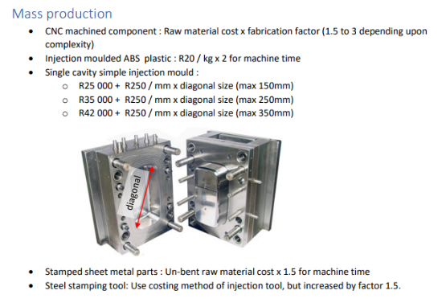

Figure 48: Tooling cost

The above figure shows the formulae that will be used to determine the costs.

The tooling cost needed to be determined for the following:

* Single cavity simple injection mould
* Steel stamping tool

Thus, the following was determined in the costing calculations (Appendix H):

* The total tooling cost came to **R424 000**.
* Three alpha prototypes will be made @R2 989
* Six beta prototypes will be made @R2 242

The total ramp-up cost came up to **R446 400**

Volume production cost per product

The volume production costs are determined using the formulae in Figure 49.

The results of the calculations are (detail calculations in Appendix H):

* Total cost of injection moulded ABS plastic is R19.38
* Total cost of CNC machined components is R2.09
* Total cost of steel stamped sheet metal components is R14.96
* Total cost of off the shelf components is R694.10
* Labour cost is R162

The volume production cost came up to **R892.53**

The table below shows a summary of values used to determine the development plan.

|  |  |  |
| --- | --- | --- |
| Development costs | R140 000 | 2 man-months @R400/h plus, 4 demonstrations prototypes @R2989 each, spread over 2 months |
| Ramp-up costs | R446 400 | Tooling @R424000, plus 3 alpha prototypes @R2989 each and 6 beta prototypes @R2242 each |
| Volume production cost per product | R892.53 | See production costing in Appendix H |
| Sales price to distributor per product | R1 400 | As per URS |
| Steady state production / sales per month | 260 | Given that 5 complete prototypes are made each day |

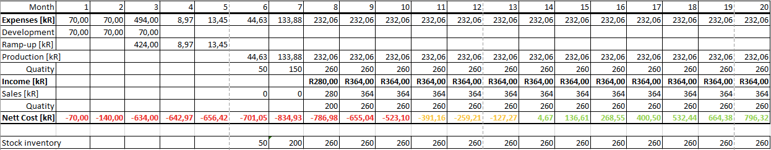

Figure 50: Cash flow analysis

The above cash flow analysis shows that the break-even point after **14 months**.

# Risks and drawbacks

The main drawback of the design is that it uses too many gears and it is because of how it is shaped. But the required moment to bend the pipe can be achieved with a smaller number of gears. Using less number benefit this design because it would make the following improvements:

* Reduce prototype cost
* Lower the prototype mass
* Reduce the number of gears that need to be supported
* Decrease the number of parts used

The main risk of the design is that if the wiring is not done correctly, it will affect the angle control mechanism. That will have the following effects:

* Fail to stop the pipe at a desired angle
* Fail to start the motor
* Fail to stop the actuator at the starting position

# Reflection

The product is designed successfully because it meets all the URS requirements. Here’s a table below showing how it meets each user requirement.

|  |  |
| --- | --- |
| User requirements | How it meets the requirement |
| B1. The manufacturing of the first prototype has a target cost of R3 000 | The prototype cost was determined to be R2989 |
| B2. For the production product, the sales target price is R1 400. | Sales target of R1400 was used to determine the break-even point |
| B3. Break-even point for the product is required within 2 years from start of volume production | The break-even point is reach after 14 months |
| C1. The device shall be battery operated. | The device is battery operated |
| C2. The battery shall be integrated into the device | The battery is integrated into the device |
| C3. The bending force shall be from an electrical motor via mechanical means only. | The bending force is due to the actuator |
| C4. Bending control shall be by means of limit switches only. | Only limit switches are used for angle control mechanism |
| F1. The device shall perform the bending and retracting action using an electric switch. | The device is able to retract using a control switch |
| F2. It shall be possible to bend a pipe that is fixed 40mm from a surface in any direction except towards the surface. | The device is able to bend the pipe fixed 40mm from a surface in any direction except toward the wall |
| F3. It shall be possible to have a free end after the bend of minimum 60 mm. | The way actuator bends the pipe and the shape of the housing allows for a minimum 60mm free end after bend |
| F4. The device shall bend the pipe to an inner radius of 15mm without pinching | A big roller with an inner radius of 15mm is used |
| . Bend angle range 45° to 90°. Fully adjustable with at least 5° increments | The device can bend the pipe from 45° to 90° and it is fully adjustable in any increments. |
| P3. Bend angle precision ± 2.5° | The device meets this precision |
| P4. Total mass < 1.5 kg | The device has a total mass of 1.447kg |
| P5. Permanent deformation of any component when fully loaded | The strength calculations are done to show that the device will not deform plasticly |
| E1. All gears and electronics shall be covered such that a rod of minimum 2mm diameter cannot contact it. | All gears are covered, and there’s no space for a rod of minimum 2mm diameter. |
| E2. The device shall be operatable by a 95% percentile adult male or female using only one hand | The device meets this requirement because it has small mass and handle to allow for one operation |
| E3. The device ergonomics shall enable maximum maneuverability and control to the user. | The switches are position close to the handle to allow for easy access and the handle is designed to allow the user to grip it. |

# References

|  |  |
| --- | --- |
| [1] | R. Hibbeler, Mechanics of Materials, SI Edition (Paperback, 10th edition), United Kingdom: Pearson Education, 2018. |
| [2] | RS Components, “RS PRO Momentary Miniature Push Button Switch, Panel Mount, SPST, 13.6mm Cutout, 32/50/125V ac, IP67,” 6 April 2023. [Online]. Available: https://za.rs-online.com/web/p/push-button-switches/7346716. |
| [3] | RS components, “Marquardt DPDT, (On)-Off-(On) Rocker Switch Panel Mount,” RS Components, 6 April 2023. [Online]. Available: https://za.rs-online.com/web/p/rocker-switches/7410820. [Accessed 6 April 2023]. |

# Appendix

## Appendix A: Bending requirements

## Appendix B: Motor calculations

## Appendix C: Gear calculations

## Appendix D: Deflection calculations

## Appendix E: Torsion calculations

## Appendix F: Strength calculations

## Appendix G: Mass calculations

## Appendix H: Cost calculations

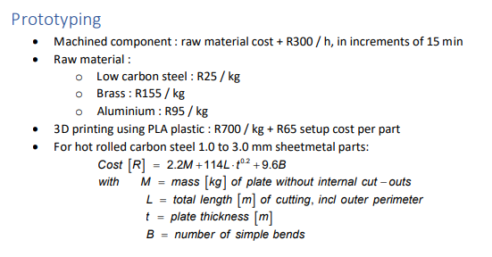

Figure 51 Typical costing inputs